**Online Benefits Payment Instructions**

1. Click [HERE](https://www.locallevelevents.com/events/details/15748) to access the online payment website. Or navigate to CCSOH.US > Staff > Employee Benefits and click on Online Benefits Payments

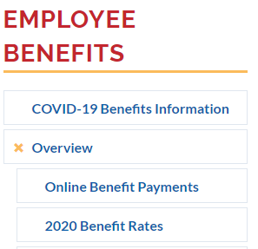

1. Click the “Pay Here!” box

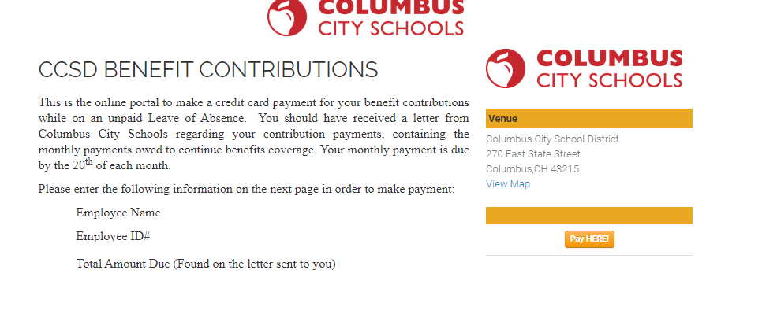

1. If you are a first time user, you will need to set up an account. Click on “Create one here.” Once the account is created, you will need to log out completely and re-select the link to log in successfully. **Make sure after you set up your account to remember your username and password for the future.**

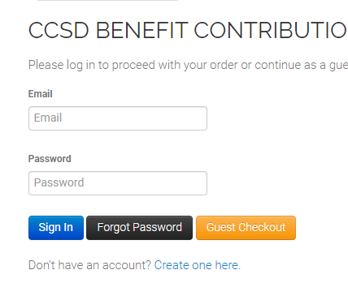

1. 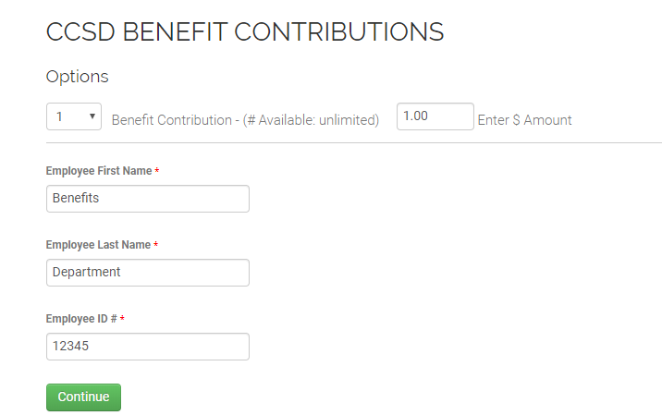Once logged in, enter your payment information on the next screen. For the “Benefit Contribution” enter 1. Enter the dollar amount you are paying in the next box. The amount you owe can be found in the letter/email your received from the Benefits Department. Enter your name and your CCS employee ID. Click “Continue”
2. Carefully review the Order Preview screen. If correct click “Continue to Payment.”

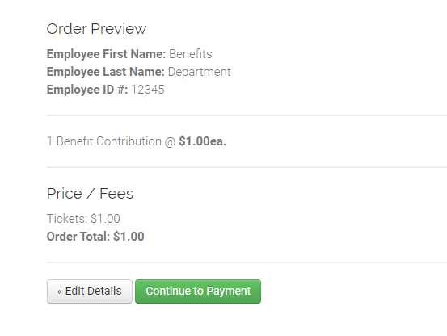

1. 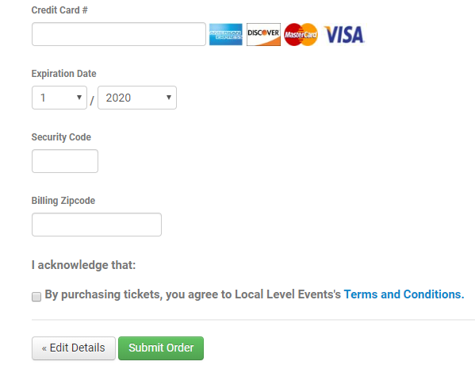On the final page, enter your credit/debit card information. Click the Acknowledgement Check Box at the bottom of the screen then click “Submit Order.”